Puzzle - Infrared Receiver 红外线接收器

产品简介
Puzzle - Infrared Receiver 红外线接收器是用来接受Puzzle - Infrared Emitter 红外线发射器的红外线信号，通常两者需要同时使用。它可以接受10m以内的红外信号。

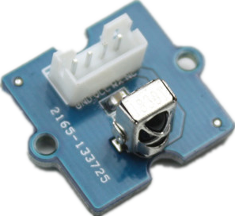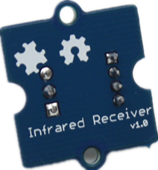
参数规格
- 工作电压: 3.3-5V
- 感应距离: 10m

应用示例
这个示例中我们同时用到了Puzzle-Infrared Receiver和Puzzle - Infrared Emitter，用红外接收器来接收红外线发射器发出的信号。
- 将Puzzle - Infrared Emitter连接至D3;
- 将Puzzle - Infrared Receiver连接至A4;

- 下载库文件file:IR Send and Receiver Library, 解压至以下路径: ..\arduino-1.0\libraries.
- 按以下路径打开文件：File -> Example ->IRSendRev->sendTest. 并将代码下载到红外线发射器对应的主控板上。
//**************
//IR sent demo v1.0
//Connect the IR sent pins to D3 for this demo
//******************************
#include <IRSendRev.h>

void setup()
{
//enableIROut(38);
}
//unsigned char d[] = {9, 90, 91, 11, 31, 4, 1, 2, 3, 4};
unsigned char d[] = {15, 70, 70, 20, 60, 10, 1, 2, 3, 4,5,6,7,8,9,10};
//Very Important:
//the first parameter(15): the data that needs to be sent;
//the next 2 parameter(70,70): the logic high and low duration of "Start";
//the next 2 parameter(20,60): the logic "short" and "long"duration in the communication
//hat to say: if "0", the high duration is 20ms and low is 20 ms; while logic "1",
//the high duration is 20 ms and low is 60 ms;
//the next 2 parameter(10): number of data you will sent;
//the next parameter(1, 2, 3, 4,5,6,7,8,9,10): data you will sent ;
void loop()
{
IR.Send(d, 38);//sent the data via 38Kz IR
delay(1000);
}

- 按以下路径打开文件: File -> Example ->IRSendRev->revTest. 并将代码下载到红外线接收器对应的主控板上。

//**************
//IR receive demo v1.0
//Connect the IR sent pins to A4 for this demo
//******************************
#include <IRSendRev.h>
//#include <IRSendRevInt.h>

void setup()
{
Serial.begin(38400);
IR.Init(A4);
Serial.println("init over");
}

unsigned char dta[20];

void loop()
{
if(IR.IsDta())
{
// IR.Recv(dta);
int length= IR.Recv(dta);
for (int i =0;i<length;i++)
{
Serial.print(dta[i]);
Serial.print("\t");
}
Serial.println();
// Very Important:
// the received data is comprised of the trsmission parameters , please refer to
// the sendTest.ino in the library ;
}
}

- 接下来打开红外线接收器对应的Serial Monitor，可以查看接受信号的情况。

参考资料
- Puzzle - Infrared Receiver eagle files
- IR Send and Receiver Library
- TSOP282 Datasheet

